Location Data Extension
This document contains the procedure for Location Data Extension for a single material.
In the URL, click on ‘Material Processing’ Location Data Extension, enter the material code for which the location data is to be extended and click on ‘ continue ‘.
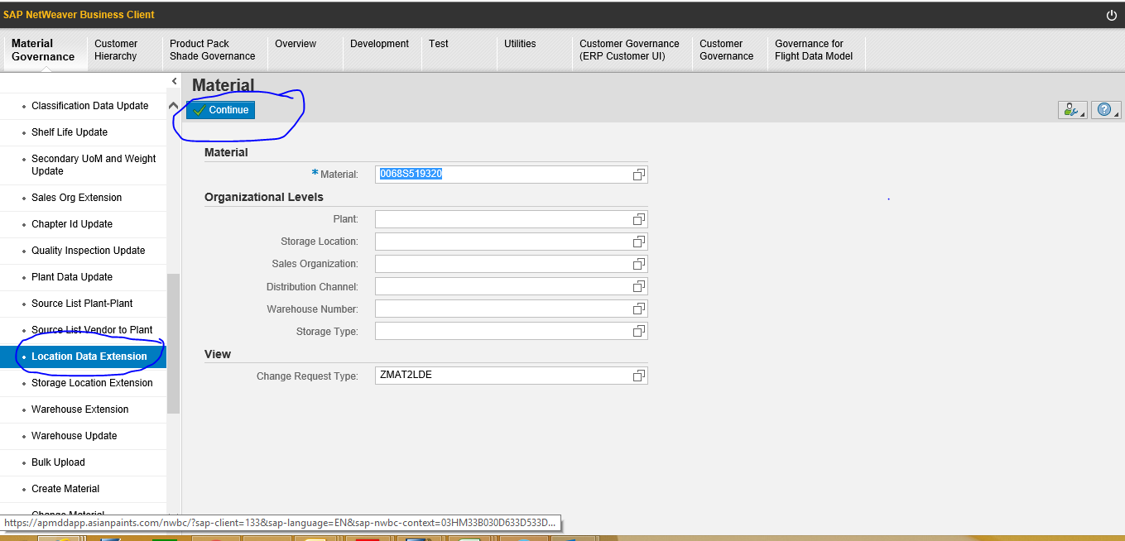
Click on ‘Edit’. Click on ‘Add’ under ‘Location Data Extension’. The available locations get displayed. Select the location in which the material is to be maintained and click on ‘Add’ in the box displaying the locations.
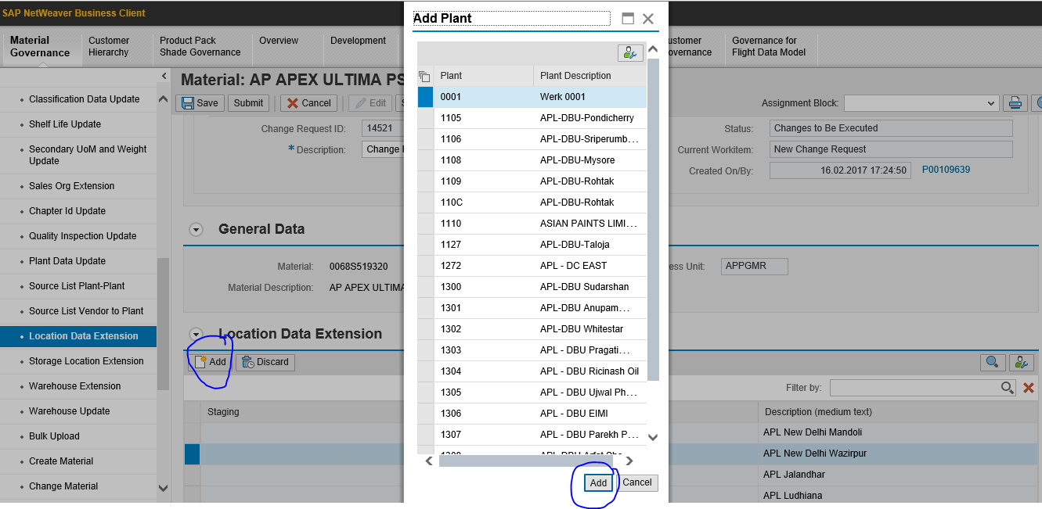
Click on ‘Check’ at the top of the screen. Only on getting ‘ no errors found’ , should you be clicking on the ‘submit’ icon.

On clicking on the ‘submit’ icon, you will get the change request number.
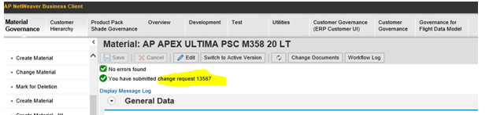
You may check in the target system ie; in Production for the desired change after about 15 minutes. Incase the required change does not reflect in Production, log an incident. Do not forget to mention the change request number in the incident
---- END ----

